Join us in Rockin’ with the
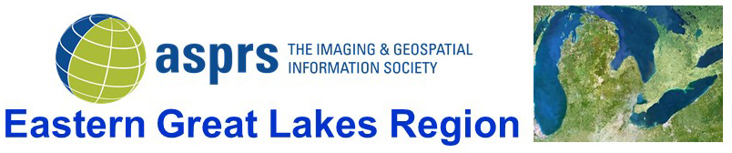
Thursday, July 28, 2022
9 a.m. – 3 p.m.
ASPRS Eastern Great Lakes Region Free 2022 Technical Meeting
“Geospatial Trends and Applications”
Keynote Address – Barbara Ryan, Executive Director World Geospatial Industry Council
Additional speakers include – Dr. Qassim Abdullah (Woolpert, Inc.), Andrew Mitchell (Kucera International), Dr. Shawana P. Johnson (Global Marketing Insights, Inc.), Joseph Cantz (CT Consultants), and Dr. Christopher Parrish (ASPRS National President and Oregon State University)
Join us at the Cleveland Metroparks Canalway Center or virtually
Followed by
ASPRS EGLR Social Outing
Rock and Roll Hall of Fame
6:30 p.m. – 9 p.m.
$21/person (group rate) - anyone attending the social will need cash or check the day of the event
Register at:
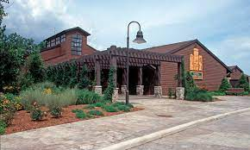
Cleveland Metroparks Canalway Center Rock and Roll Hall of Fame
4524 East 49th Street 1100 East 9th Street
Cuyahoga Falls, OH 44125 Cleveland, OH 44114

